A professional quality wheel paint, ideal for renewing and extending the life of worn or damaged wheels. RAPTOR Wheel Paint’s advanced formula resists temperatures up to 250°F and provides superior protection from impact, heat, stone chips, brake dust and corrosion.
 | - Heat resistant up to 250°F
- Superior adhesion
- Professional quality
Product |  |  |  | Order Code | Format |  |  |  | Shelf Life
RAPTOR Wheel Paint Gloss Black  RAPTOR Wheel Paint Satin Black |  |  |  | UP4909  UP4907 | 10oz Aerosol  10oz Aerosol |  |  |  | 2 years  2 years
APPLICATION INFORMATION
 |  | IMPORTANT: FOR PROFESSIONAL USE ONLY. Read full instructions before use. This product contains hazardous materials and therefore appropriate personal protective equipment should always be used. Please refer to the label and consult the safety data sheet for full handling instructions and personal protection information.
Surface Preparation |  | Substrate  - RAPTOR Acid etch primer for metals  - RAPTOR Adhesion Promoter on plastics |  | Degreaser |  |  |  |  | Abrasion  - P180-P220 before application  - P400-P600 for Acid etch primed suface  - P800-Scotch pad after 6 hours
 |  | HOW TO USE:
1. Clean and degrease. Mask areas as required.
2. Sand surface with P180-P220 sandpaper and reclean.
3. Prime any areas of bare metal with RAPTOR Acid Etch Primer. When dry, sand with P400-P600
sandpaper and reclean.
4. For plastic parts and difficult to sand areas, prime the surface with RAPTOR Adhesion Promoter.
5. Thoroughly shake can for at least 2 mins before use.
6. Always wear safety goggles and rubber gloves before spraying.
7. Apply 2 coats @ 6-10 inches from surface, waiting 5-10 mins between coats.
8. To clean – invert can and spray until only propellent sprays.
9. Touch dry in 30 mins at 70°F. Allow to dry overnight before use
Mixing |  | Shake the aerosol can for at least 2 minutes before use. Reshake for 30 seconds between coats.
Application  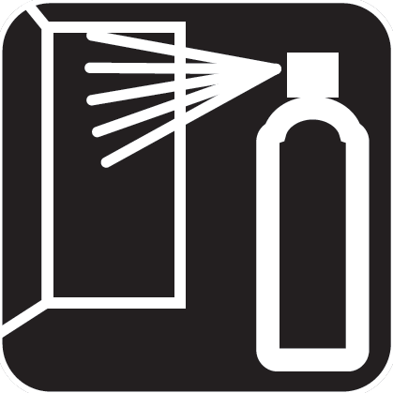 |  | Application Temperature |  | 70 °F
 |  | Distance from the surface |  | 15-25 cm / 6-10 inches
 |  | Flash-off at 70°F |  | 5-10 mins
 |  | Dust Free at 70°F |  | 30 mins
 |  | Number of Coats  Overcoating |  | 2-3  Up to 6 hours, If allowed to dry longer than 6 hours, then abrade with P800- Scotch pad
TECHNICAL INFORMATION
Physical properties
 |  | Appearance |  | aerosol.
 |  | Color |  | Black
Storage |  | Aerosol cans should be stored for two hours at room temperature before use. For long term storage, keep in a dry well ventilated area and away from direct sunlight and frost. To clear the nozzle and maximise the lifespan of your aerosol, always invert the can and spray upside down for a few seconds after each use. Should the nozzle become blocked, remove it from the can and soak it in gentle thinners.
 |  | Protect from sunlight. Do not expose to temperatures exceeding 122 °F. Store locked up. Store in a well-ventilated place. Keep container tightly closed. Keep cool. Keep only in original container.
 |  | Recommended storage temperature |  | 41 - 77 °F
Associated Products |  | Product |  |  |  |  | Order Code |  |  | Format
 |  | RAPTOR Wheel Paint Gloss Black  RAPTOR Wheel Paint Satin Black |  |  |  |  | UP4909  UP4907 |  |  | 10oz Aerosol  10oz Aerosol

