A professional quality, flameproof paint, ideal for use on exhaust manifolds, headers, exhaust systems and other surfaces that require protection from very high heat. RAPTOR Flameproof is based on an advanced ceramic technology and high heat resistant pigments that withstand temperatures up to 2000°F.
 | - Heat resistant intermittently up to 2000 ºF
- Superior adhesion
- Good chemical resistance against automotive fluids and common solvents when cured
Product |  |  |  | Order Code | Format |  |  |  |  |  | Shelf Life
RAPTOR FLAMEPROOF FLAT BLACK AEROSOL  RAPTOR FLAMEPROOF FLAT RED AEROSOL |  |  |  | UP4942  UP4943 | 10oz Aerosol  10oz Aerosol |  |  |  |  |  | 2 years  2 years
APPLICATION INFORMATION
 |  | IMPORTANT: FOR PROFESSIONAL USE ONLY. Read full instructions before use. This product contains hazardous materials and therefore appropriate personal protective equipment should always be used. Please refer to the label and consult the safety data sheet for full handling instructions and personal protection information.
Surface Preparation |  | Substrate  - RAPTOR Flameproof Primer  - Bare steel*  - Aluminium*  - Galvanised steel*  - Stainless steel*  - Titanium* |  | Degreaser:  - Waterbased degreaser  - Isopropyl Alcohol 70/30  Do not use mineral spirit |  |  |  |  | Abrasion  - P180 before application and for cured paint  - Denib: From P500 or Scotch pad  - Sand: P500 after 12h
*Can be applied direct to metal. To achieve maximum performance (Adhesion, heat resistance…), RAPTOR Flameproof Primer must be applied prior to applying RAPTOR Flameproof Coating.

HOW TO USE:
1. Clean and degrease. Mask any areas as required.
2. Apply RAPTOR Flameproof primer according to TDS for best result or sand surface with P180-P220 sandpaper and reclean.
3. Thoroughly shake can for at least 2 mins before use.
4. Always wear safety goggles and rubber gloves before spraying.
5. Apply 2 coats @ 10 inches from surface, waiting 10 mins between coats.
6. To clean – invert can and spray until only propellent sprays.
7. Touch dry in 30 mins @70°F. Can be directly overcoated with RAPTOR Flameproof Satin Clear after 30mins or allow RAPTOR Flameproof Coating to dry for 1 hour and denib as required, then degrease, only use waterbased degreaser applied to the cloth to avoid soaking of the surface.
8. Overcoat with RAPTOR Flameproof Satin Clear if wanted.
9. Once all coats applied, allow to dry for a minimum of 4 hours (Drying overnight is recomanded) to allow the solvents to leave the film and then follow the steps to obtain the full cure:
If on the vehicle, run at idle for at least 30 mins. Let it cool down and run again under normal conditions for at least 30 mins.
If off the vehicle, bake at 475°F for 1 hour.
Mixing |  | Shake the aerosol can for at least 2 minutes before use. Reshake for 30 seconds between coats.
Application  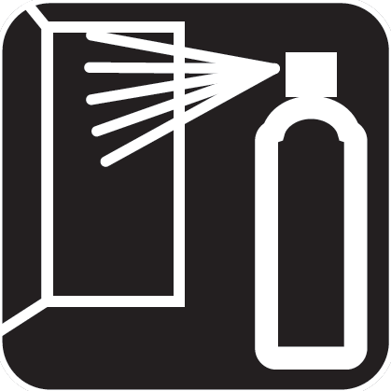 |  | Application Temperature |  | 70 °F
 |  | Distance from the surface |  | 10 inches
 |  | Flash-off at 70°F |  | 10 mins
 |  | Dust Free at 70°F |  | 30 mins
 |  | Number of Coats |  | 2-3
Overcoating |  | Overoating window: Up to 12 hours. If allowed to dry longer than 12 hours, abrade with 500 grit, clean with waterbased degreaser then re-apply  NOTE: There is no need to cure between primer, topcoat and clearcoat but it is needed after the full system is applied.  If you want to overcoat after curing the coating, abrade with P180 and touch up if substrate is showing through
TECHNICAL INFORMATION
Physical properties
 |  | Appearance |  | aerosol.
 |  | Colors |  | Black, Red
Storage |  | Aerosol cans should be stored for two hours at room temperature before use. For long term storage, keep in a dry well ventilated area and away from direct sunlight and frost. To clear the nozzle and maximise the lifespan of your aerosol, always invert the can and spray upside down for a few seconds after each use. Should the nozzle become blocked, remove it from the can and soak it in gentle thinners.
 |  | Protect from sunlight. Do not expose to temperatures exceeding 122 °F. Store locked up. Store in a well-ventilated place. Keep container tightly closed. Keep cool. Keep only in original container.
 |  | Recommended storage temperature |  | 41 - 77 °F
Associated Products |  | Product |  |  |  |  | Order Code |  |  | Format
 |  | RAPTOR FLAMEPROOF GREY PRIMER AEROSOL  RAPTOR FLAMEPROOF FLAT BLACK AEROSOL  RAPTOR FLAMEPROOF FLAT RED AEROSOL  RAPTOR FLAMEPROOF SATIN CLEAR AEROSOL |  |  |  |  | UP4941  UP4942  UP4943  UP4941 |  |  | 10oz Aerosol  10oz Aerosol  10oz Aerosol  10oz Aerosol

