A professional quality primer for use prior to the application of RAPTOR Engine Enamel. Ideal for use on engine blocks, engine accessories and other surfaces in the engine compartment. When used in combination with RAPTOR Engine Enamel, it provides a finish which resists temperatures up to 600ºF
 | - Heat resistant up to 600ºF
- Superior adhesion and corrosion resistance
- Good chemical resistance against automotive fluids when cured
Product |  |  | Order Code | Format |  |  |  |  | Shelf Life
RAPTOR ENGINE ENAMEL PRIMER AEROSOL |  |  | UP4920 | 10oz Aerosol |  |  |  |  | 2 years
APPLICATION INFORMATION
 |  | IMPORTANT: FOR PROFESSIONAL USE ONLY. Read full instructions before use. This product contains hazardous materials and therefore appropriate personal protective equipment should always be used. Please refer to the label and consult the safety data sheet for full handling instructions and personal protection information.
Surface Preparation |  | Substrate  - Bare steel  - Aluminium  - Galvanised and zinc coated sheets  - Fully cured paint  - Polyester bodyfillers and G.R.P | Degreaser |  |  |  | Abrasion  - P180-P220 cured primer  - P400-P600 before overcoating
 |  | HOW TO USE:
1.Clean and degrease. Mask any areas as required.
2. Sand surface with P180-P220 sandpaper and reclean.
3. Thoroughly shake can for at least 2 mins before use.
4. Always wear safety goggles and rubber gloves before spraying.
5. Apply 2 coats @ 10 inches from surface, waiting 5-10 mins between coats.
6. To clean – invert can and spray until only propellent sprays.
7. Touch dry in 30 mins at 70°F. Allow Engine Enamel Primer to dry for 1 hour and sand with P400-P600
sandpaper before overcoating with RAPTOR Engine Enamel top coat.
Mixing |  | Shake the aerosol can for at least 2 minutes before use. Reshake for 30 seconds between coats.
Application  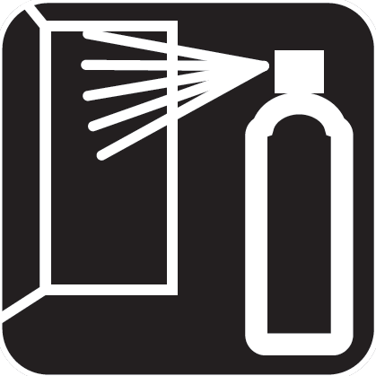 |  | Application Temperature | 70 °F
 |  | Distance from the surface | 25 cm / 10 inches
 |  | Flash-off at 70°F | 10 mins
 |  | Dust Free at 70°F | 30 mins
 |  | Number of Coats | 2-3
Overcoating |  | Overoating window: Up to 4 hours. If allowed to dry longer than 4 hours, wait 24h for the primer to fully cure then abrade with P180-P220 GRIT, degrease and re-apply RAPTOR Engine enamel primer before overcoating.  NOTE: There is no need to cure between primer, topcoat and clearcoat but it is needed after the full system is applied.
TECHNICAL INFORMATION
Physical properties
 |  | Appearance | aerosol.
 |  | Color | Grey
Storage |  | Aerosol cans should be stored for two hours at room temperature before use. For long term storage, keep in a dry well ventilated area and away from direct sunlight and frost. To clear the nozzle and maximise the lifespan of your aerosol, always invert the can and spray upside down for a few seconds after each use. Should the nozzle become blocked, remove it from the can and soak it in gentle thinners.
 |  | Protect from sunlight. Do not expose to temperatures exceeding 122 °F. Store locked up. Store in a well-ventilated place. Keep container tightly closed. Keep cool. Keep only in original container.
 |  | Recommended storage temperature | 41 - 77 °F
Associated Products |  | Product |  |  | Order Code |  |  | Format
 |  | RAPTOR ENGINE ENAMEL PRIMER AEROSOL  RAPTOR ENGINE ENAMEL BRIGHT RED AEROSOL  RAPTOR ENGINE ENAMEL FLAT BLACK AEROSOL  RAPTOR ENGINE ENAMEL SATIN BLACK AEROSOL  RAPTOR ENGINE ENAMEL GLOSS BLACK AEROSOL  RAPTOR ENGINE ENAMEL GLOSS CLEAR AEROSOL |  |  | UP4920  UP4921  UP4924  UP4923  UP4922  UP4925 |  |  | 10oz Aerosol

