A professional quality enamel, ideal for customising and extending the life of brake calipers. RAPTOR Caliper Enamel contains ceramic resins that resist temperatures up to 950°F
 | - Heat resistant up to 950°F
- Superior adhesion and corrosion resistance
- Good chemical resistance against automotive fluids when cured
Product |  |  | Order Code | Format |  |  | Shelf Life
RAPTOR CALIPER ENAMEL REAL RED AEROSOL  RAPTOR CALIPER ENAMEL SATIN BLACK AEROSOL |  |  | UP4931  UP4930 | 10oz Aerosol |  |  | 2 years
APPLICATION INFORMATION
 |  | IMPORTANT: FOR PROFESSIONAL USE ONLY. Read full instructions before use. This product contains hazardous materials and therefore appropriate personal protective equipment should always be used. Please refer to the label and consult the safety data sheet for full handling instructions and personal protection information.
Surface Preparation |  | Substrate  - Bare steel  - Aluminium  - Galvanised and zinc coated sheets  - Fully cured paint  - Stainless steel | Degreaser |  |  |  | Abrasion  - P180-P220 before application  - P400-P600 on primed surfaces  - P800-P1000 for cured paint
 |  | HOW TO USE:
1.Clean and degrease. Mask any areas as required
2. Sand surface with P180-P220 sandpaper and reclean.If primed, sand with P400-P600 sandpaper & reclean.
3 Thoroughly shake can for at least 2 mins before use.
4. Always wear safety goggles and rubber gloves before spraying.
5. Apply 2 coats @ 6-10 inches from surface, waiting 5-10 mins between coats.
6. To clean – invert can and spray until only propellent sprays.
8. Touch dry in 30 mins at 70°F. Ready to handle in 2hrs. Wait a minimum of 5 hours before use
9. Cure the coating:
If on the vehicle, the heat generated by the breaking operation will achieve full cure
If off the vehicle, bake at 200°F for 1 hour.
Mixing |  | Shake the aerosol can for at least 2 minutes before use. Reshake for 30 seconds between coats.
Application  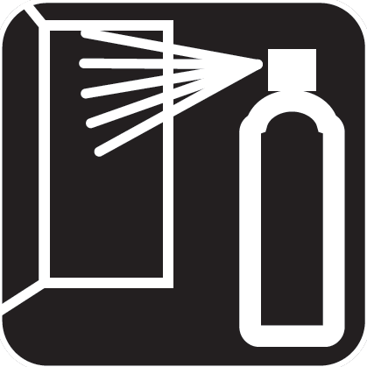 |  | Application Temperature | 70 °F
 |  | Distance from the surface | 6-10 inches
 |  | Flash-off at 70°F | 10 mins
 |  | Dust Free at 70°F | 30 mins
 |  | Number of Coats | 2-3
Overcoating |  | Overoating window: Up to 2 hours. If allowed to dry longer than 2 hours, wait 24h for paint to cure then abrade with P800-P1000 GRIT, degrease then re-apply.  NOTE: If you want to overcoat after curing the coating, abrade with P800-P1000 and touch up if substrate is showing through
TECHNICAL INFORMATION
Physical properties
 |  | Appearance | aerosol.
 |  | Color | Red, Black
Storage |  | Aerosol cans should be stored for two hours at room temperature before use. For long term storage, keep in a dry well ventilated area and away from direct sunlight and frost. To clear the nozzle and maximise the lifespan of your aerosol, always invert the can and spray upside down for a few seconds after each use. Should the nozzle become blocked, remove it from the can and soak it in gentle thinners.
 |  | Protect from sunlight. Do not expose to temperatures exceeding 122 °F. Store locked up. Store in a well-ventilated place. Keep container tightly closed. Keep cool. Keep only in original container.
 |  | Recommended storage temperature | 41 - 77 °F
Associated Products |  | Product |  |  | Order Code |  |  | Format
 |  | RAPTOR CALIPER ENAMEL REAL RED AEROSOL  RAPTOR CALIPER ENAMEL SATIN BLACK AEROSOL |  |  | UP4931  UP4930 |  |  | 10oz Aerosol

